COMPUTER NETWORKS LAB

REPORT ASSIGNMENT-6

NAME: SOHAM LAHIRI

CLASS: BCSE UG-III 5TH SEMESTER

ROLL NO: 002210501107

GROUP: A3

SUBMISSION DATE: 18/11/2024

Problem Statement:
1.Connect two hosts back-to-back with a crossover cable. Assign IP addresses, and see whether they are able to ping each other.

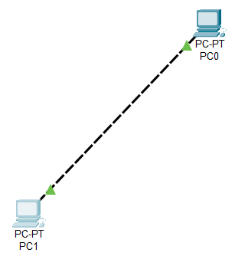

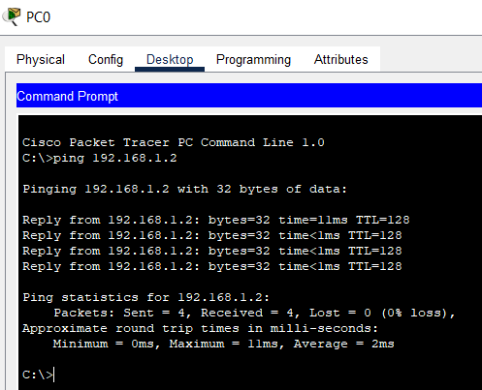
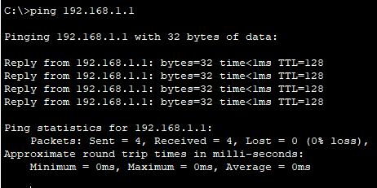

2. Create a LAN (named LAN-A) with 3 hosts using a hub. Ping each pair of nodes.

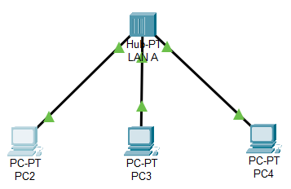
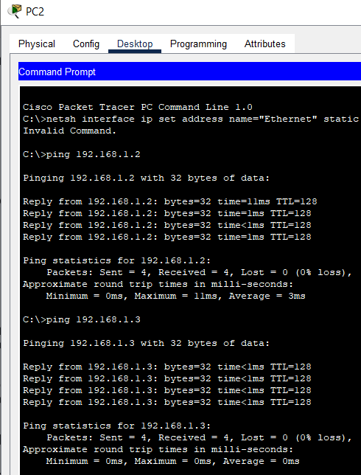
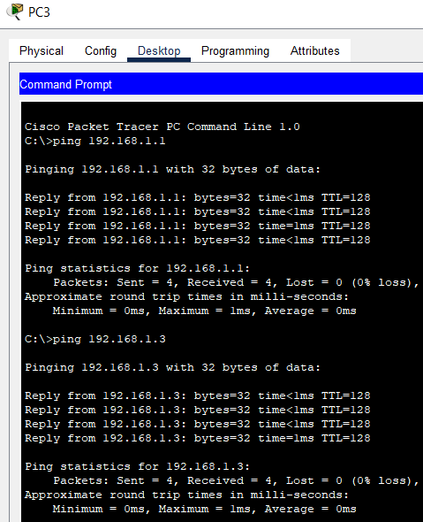
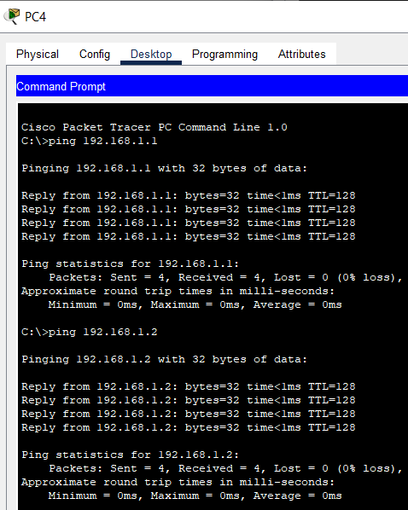

3. Create a LAN (named LAN-B) with 3 hosts using a switch. Record contents of the ARP Table of end
hosts and the MAC Forwarding Table of the switch. Ping each pair of nodes. Now record the contents
of the ARP Table of end hosts and the MAC Forwarding Table of the switch again.
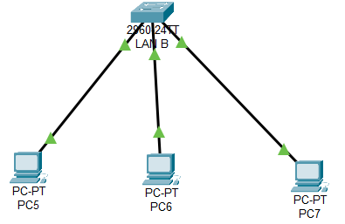
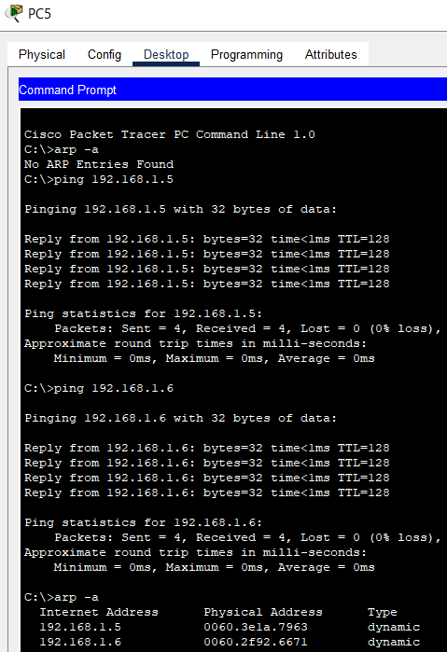
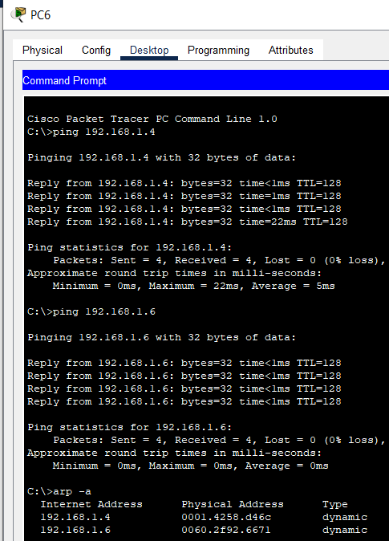
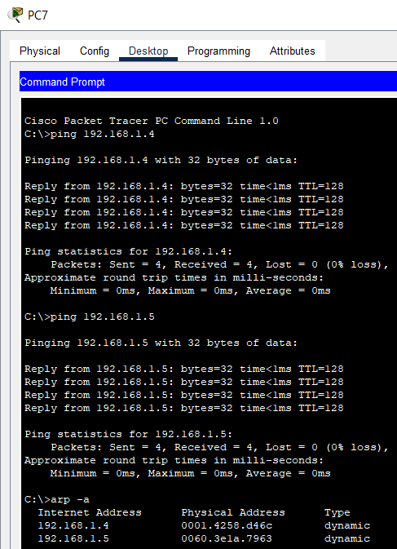
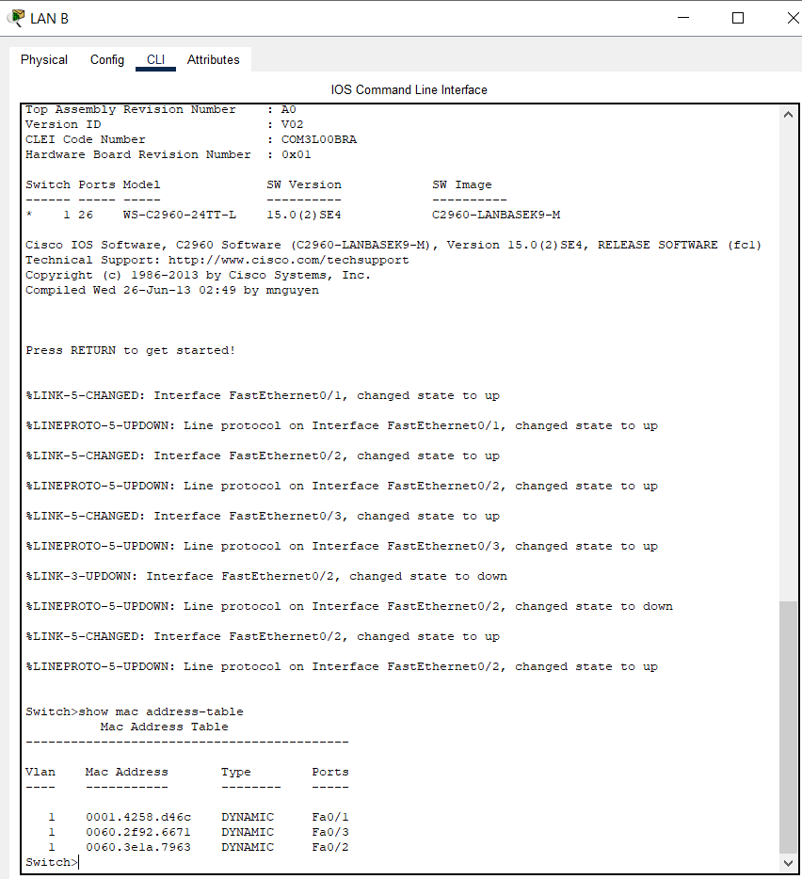

4. Connect LAN-A and LAN-B by connecting the hub and switch using a crossover cable. Ping between each pair of hosts of LAN-A and LAN-B. Now record the contents of the ARP Table of end hosts and the MAC Forwarding Table of the switch again.
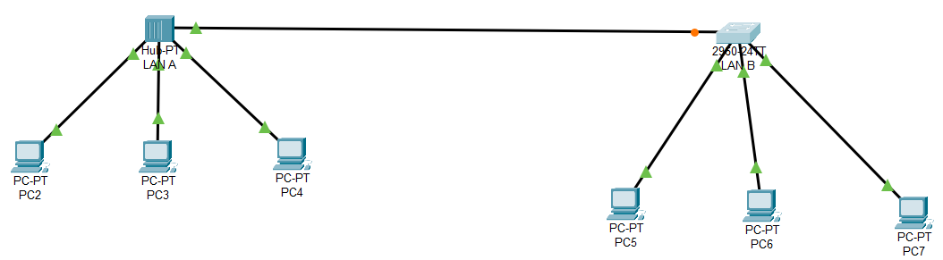
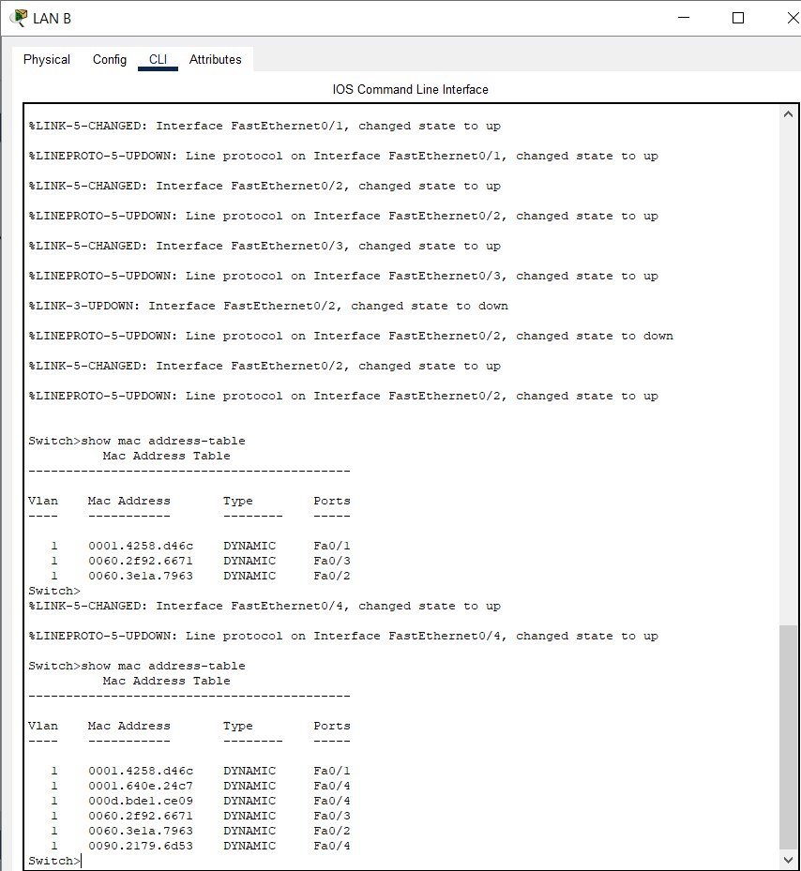
5. Create a LAN (named JU-Main) with three hosts connected via a layer-2 switch (Cisco 2950 switch PC-LAB1-Switch). Connect the switch to a router (Cisco 1818). Assign IP addresses to all the hosts and the router interface connected to this LAN from network 192.168.148.0/24. Configure the default gateway of each host as the IP address of the interface of the router which is connected to the LAN. Create another LAN (named JU-SL) with three hosts connected via a layer-2 switch (Cisco 2950 switch PC-LAB2-Switch). Connect this switch to another router (Cisco 1818). Assign IP addresses to all the hosts and the router interface connected to this LAN from network 192.168.149.0/24.
Configure the default gateway of each host as the IP address of the interface of the router which is connected to the LAN. Connect the two routers through appropriate WAN interfaces. Assign IP addresses to the WAN interfaces from network 192.168.150.0/24. Add static route in both of the routers to route packets between two LANs.
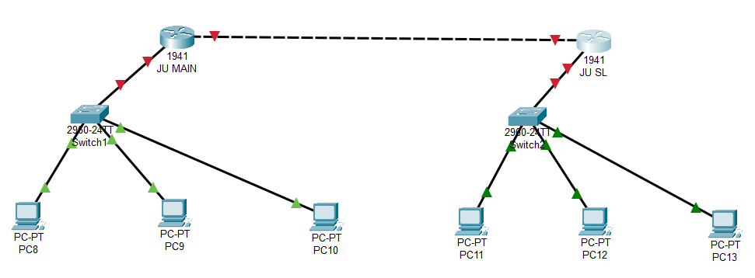
Step-by-Step Configuration
1. Configure Hosts in JU-Main LAN
- Host 1 in JU-Main: IP: 192.168.148.10, Subnet Mask: 255.255.255.0, Default Gateway: 192.168.148.1 (Router1).
- Host 2 in JU-Main: IP: 192.168.148.11, Subnet Mask: 255.255.255.0, Default Gateway: 192.168.148.1 (Router1).
- Host 3 in JU-Main: IP: 192.168.148.12, Subnet Mask: 255.255.255.0, Default Gateway: 192.168.148.1 (Router1).
2. Configure Hosts in JU-SL LAN
- Host 1 in JU-SL: IP: 192.168.149.10, Subnet Mask: 255.255.255.0, Default Gateway: 192.168.149.1 (Router2).
- Host 2 in JU-SL: IP: 192.168.149.11, Subnet Mask: 255.255.255.0, Default Gateway: 192.168.149.1 (Router2).
- Host 3 in JU-SL: IP: 192.168.149.12, Subnet Mask: 255.255.255.0, Default Gateway: 192.168.149.1 (Router2).
3. Configure Router1 (Connected to JU-Main)
- Router1 (Cisco 1818) Interface for JU-Main:
  - Interface: GigabitEthernet0/1
  - IP Address: 192.168.148.1
  - Subnet Mask: 255.255.255.0
- Router1 (Cisco 1818) WAN Interface:
  - Interface: GigabitEthernet0/2
  - IP Address: 192.168.150.1
  - Subnet Mask: 255.255.255.0
- Routing Configuration on Router1:
  - Set the static route to reach JU-SL via the WAN:
4. Configure Router2 (Connected to JU-SL)
- Router2 (Cisco 1818) Interface for JU-SL:
  - Interface: GigabitEthernet0/1
  - IP Address: 192.168.149.1
  - Subnet Mask: 255.255.255.0
- Router2 (Cisco 1818) WAN Interface:
  - Interface: GigabitEthernet0/2
  - IP Address: 192.168.150.2
  - Subnet Mask: 255.255.255.0

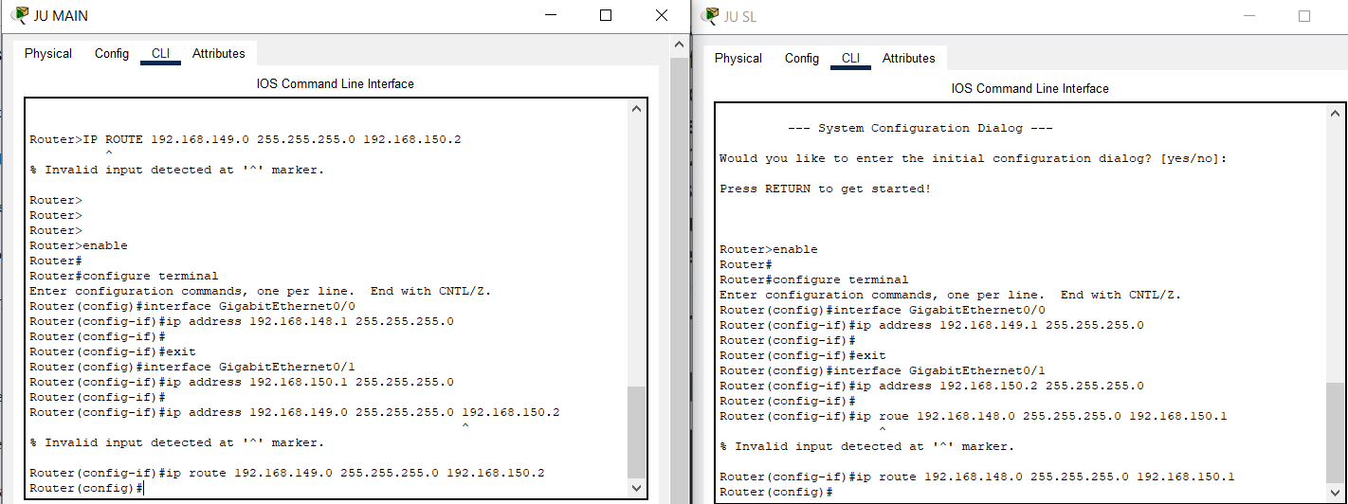

6. Add servers to the individual LANs (in problem 5) and configure them as a DHCP server. Configure the hosts in the individual LAN to obtain IP addresses and address of the default gateway via this DHCP server.
Set Up DHCP Server in JU-Main
- DHCP Server Configuration for JU-Main:
  - Server IP Address: 192.168.148.20 (assigned to the DHCP server in JU-Main).
  - Subnet Mask: 255.255.255.0.
  - DHCP Range: 192.168.148.100 to 192.168.148.200.
  - Default Gateway: 192.168.148.1 (Router1).
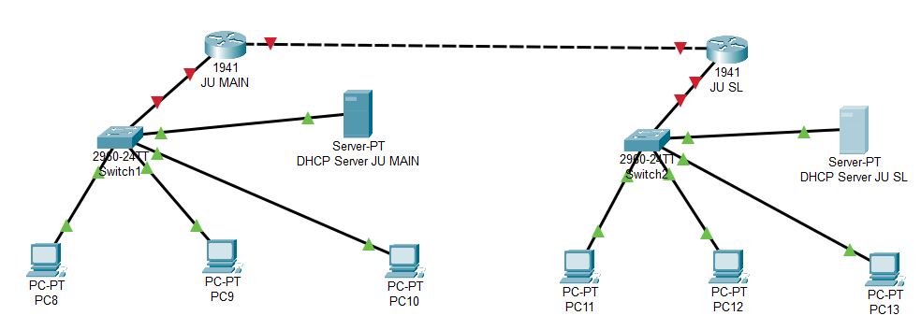

7. Create a LAN (CSE) with three hosts connected via a layer-2 switch (Cisco 2950 switch CSE-Switch). Also add a web server and a ftp server to this LAN. The hosts dynamically get their IP addresses from a local DHCP server. Servers are assigned fixed IP addresses. Configure the individual hosts to use
the local DNS server for name resolution. Add a Domain Name Server (DNS) to this LAN. Create appropriate records in the DNS server for the individual servers in the LAN. The domain name of the LAN is cse.myuniv.edu. Configure the individual hosts to use the local DNS server for name resolution.

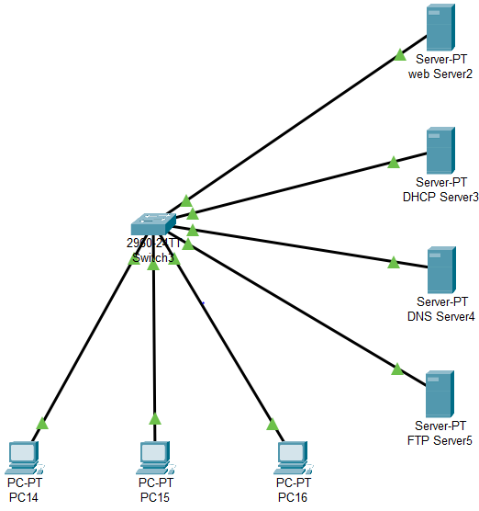
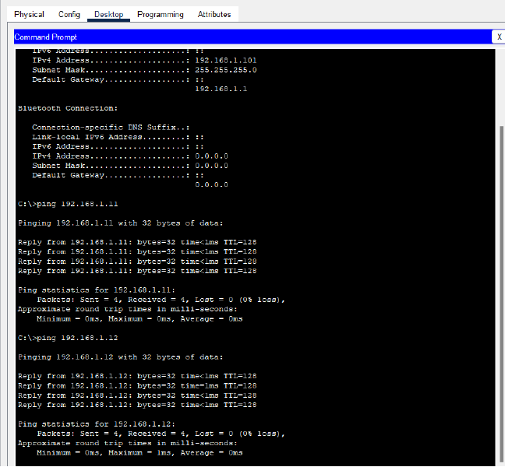

COMMENTS:

This assignment has significantly enhanced my understanding of network design and configuration, particularly through the hands-on implementation of LANs and router connectivity using Cisco devices. By setting up multiple LANs with dynamic IP addressing via DHCP, configuring DNS and DHCP servers, and connecting networks through routers and switches, I gained valuable insights into the practical aspects of networking, including the importance of IP management, routing, and domain name resolution. Additionally, the exercise in configuring servers and ensuring seamless communication between devices deepened my understanding of how data flows across networks, ensuring efficient and secure communication. I would like to extend my sincere gratitude to our instructor for their guidance throughout this process, as their support has been instrumental in helping me grasp the complexities of networking protocols and configuration.

